C964 Computer Science Capstone
  - Part D: Other Documentation

Accuracy Assessment
Assessing the accuracy of a generative AI agent is more complex than measuring a traditional classification model, which has a simple right-or-wrong answer. For this project, a correct response is one that is syntactically valid, adheres to the user's complex intent (including the AVM/Classic toggle), and is properly grounded in the retrieved RAG context.
Therefore, I assessed the data product's accuracy using a multi-layered approach, combining quantitative training metrics with qualitative, human-in-the-loop validation.

Metric 1: Model Training Performance (Training & Token Accuracy)
This metric assesses the machine learning model's fundamental ability to learn its new, complex task: generating a strict JSON schema.
- What it is: During the fine-tuning job in Azure AI Foundry, the platform automatically generates graphs for Training Loss and Token Accuracy.
- How it was Used:
  - Training Loss: This graph plots the model's error rate over time. We verified that the “loss” line went down steeply and then plateaued, which is the classic sign of a successful training run. This confirms the model "learned" from the data.
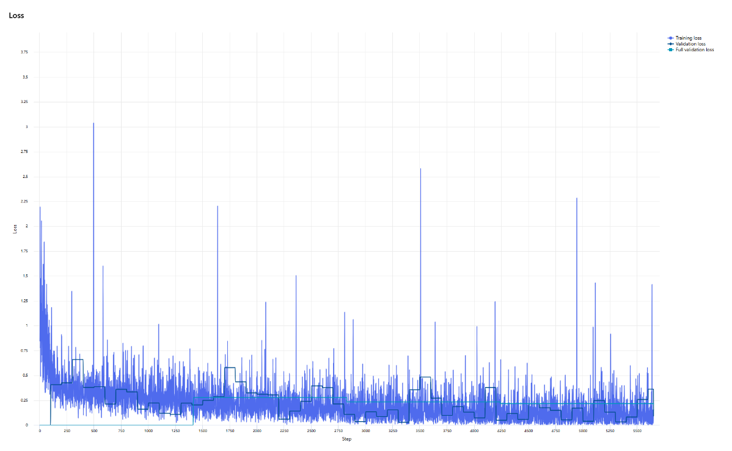
Figure 1: Training Loss Graph (copy may be found in the visualizations folder)
  - Token Accuracy: This graph measures the percentage of time the model correctly predicted the very next token (e.g., a comma, a bracket, a keyword) in the training data. For our agent, achieving a high token accuracy (e.g., >90%) was critical.
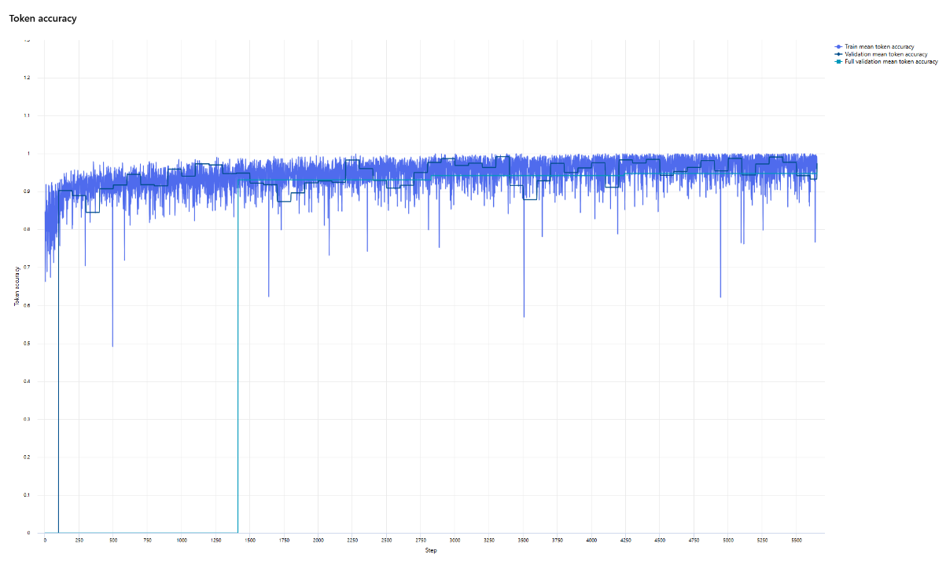
Figure 2: Token Accuracy Graph (copy may be found in the visualizations folder)
- Assessment: The high, stable token accuracy and low, stable loss from the fine-tuning job confirmed that the model successfully learned the complex syntax of the JSON output structure, which was the primary goal of the fine-tuning.

Metric 2: End-to-End System Validation (Manual Evaluation)
This metric assesses the accuracy of the entire system (UI Toggle -> Filter Logic -> RAG -> AI Generation) against a predefined set of test cases.
- What it is: I used the 10+ prompts from the example prompts (e.g., "AVM storage account," "classic vnet") and their "ground truth" correct Bicep answers.
- How it was Used: I ran each prompt from the through the web application's UI, once with the "AVM Mode" toggle ON and once with it OFF. We then manually graded the resulting Bicep code.
- Assessment (Pass/Fail Criteria):
  - Correct Logic? Did the app generate an AVM module when AVM was toggled ON, and a resource when OFF?
  - Correct Context? Did the generated code use the correct, versioned module path (e.g., ...:0.8.0) from the RAG context, or did it hallucinate a path (e.g., .../avmdev)?
  - Correct Parameters? Did the code correctly parse parameters from the user's prompt (e.g., sku: 'Standard_ZRS')?
Initial tests using this method revealed critical failures, such as hallucinations, which were fixed by correcting our RAG data and re-fine-tuning. The final system passes these validation tests, confirming its end-to-end accuracy.

Metric 3: Bicep Code Validity (Bicep Compilation)
This metric provides a development plan for an automated accuracy check: ensuring the code is not just plausible, but syntactically deployable.
- What it is: A plan to programmatically run the bicep build command on the generated code.
- How it would be Used (Future Plan): As outlined in the "Roadmap," a future enhancement would be to add a /validate endpoint to the application. This endpoint would take the generated Bicep code and execute bicep build on it.
- Assessment: This provides a simple, automated, binary metric of "Compilation Pass/Fail Rate." This serves as an excellent, non-human-in-the-loop guardrail to catch model-generated syntax errors, directly measuring the validity of the product.

